Gender Pay Gap Report - Snapshot Data 31st March 2024

The Warriner Multi Academy Trust is made up of one secondary and six primary schools. As we employ over 250 employees, we are required by law to carry out gender pay gap reporting under the Equality Act 2010. Gender pay gap reporting requires us to make calculations based on colleagues’ gender and their pay based on the snapshot date of 31 March 2024.
This report will be published on our website: www.warrinermultiacademytrust.co.uk

Gender pay gap:
These are the differences between the middle man and woman (Median) and the average man and woman (Mean). Their pay is calculated to an adjusted hourly rate using the methodology prescribed by the legislation. Please note that the gender pay gap is defined as the relative difference in the average gross hourly earnings of women and men. It is not a direct comparison of women and men in the same roles but a comparison of females and males across all roles within the Trust. Therefore the data reported here is not to be confused with our obligation to pay equally for equal work.

Snapshot date: 31st March 2024

Difference in mean and median hourly rates of pay
 | Difference in the mean hourly pay | Difference in the median hourly pay
Pay gap. % difference male to female | 21.12% | 46.58%

Difference in mean and median bonus pay
 | Difference in the mean bonus pay | Difference in the median bonus pay
Pay gap. % difference male to female | N/A Staff do not receive bonus payments | N/A Staff do not receive bonus payments

Proportion of male and female employees who were paid bonus pay
 | Proportion receiving a bonus
Male employees (% paid a bonus compared to all male employees) | N/A Staff do not receive bonus payments
Female employees (% paid a bonus compared to all female employees) | N/A Staff do not receive bonus payments

Proportion of male and female employees according to quartile pay bands
 | Quartile 1 (lower) | Quartile 2. (lower middle) | Quartile 3 (upper middle) | Quartile 4 (upper)
Male (% males to all employees in each quartile) | 14.63% | 14.29% | 22.89% | 27.71%
Female (% females to all employees in each quartile) | 85.37% | 85.71% | 77.11% | 72.29%

Supporting statement
I can confirm that the information published here is accurate.

Signature: …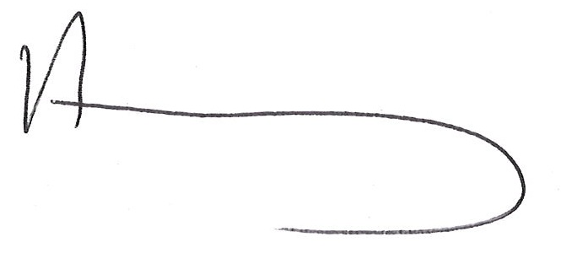……………………………………………………………………... Date: …06/03/2025

Status/Position: …Dr Annabel Kay CEO/Headteacher………………………………………………………………..
The 2024 data shows an increase in the median pay gap and a decrease in the mean gender pay gap. The data in the lower quartiles reflects the percentages, having more women in lower paid roles. These roles are predominantly part time term time only roles such as teaching assistants, administrators, lunchtime assistants, invigilators which are historically roles taken by females. Any notional gender pay gap that exists is due to staffing demographic within the Trust and is noted elsewhere within the education sector. The highest percentage for the Upper Quartile are female.

The Trust continues to be committed to reducing its gender pay gap. We undertake a number of initiatives to support all staff in the workplace.

Equal Pay: Our staff are paid following national pay scales; for teachers we use the pay scales published in the Teachers Pay and Conditions Document, and for support staff, the National Joint Council Pay and Conditions. We also have a job evaluation scheme in place for support staff. We believe both men and women are paid equally for similar roles across the MAT.
Recruitment: All advertisements are transparent regarding salary for the post. We shortlist against clear criteria contained in Person Specifications.
CPD: We are committed to providing all staff with the very best CPD and career opportunities. CPD opportunities are available to all staff
Flexible Working: The Trust offers a Flexible Working Scheme. The school will consider all requests for flexible working. The school recognises that people work more effectively when they are able to strike a healthy balance between their work responsibilities and other aspects of their lives.
Equality: One of our key equality objectives is to ensure that the promotion of equality and human rights and elimination of discrimination and harassment is embedded in practice throughout all our schools.

The aim of the Warriner Multi Academy Trust Equality Policy Impact Statement is to show our compliance with the Public Sector Equality Duty by demonstrating the impact of our Equality Policy and the progress towards our Equality Objectives. This can be read in conjunction with our Single Equality Policy; all policies available on the WMAT website.

